DataLoader
& Auto Scheduled Task in Win

Check doc salesforce_data_loader.pdf
Folder dls/
1 create DataLoader key file (with key inside to encrypt pswrd – any key it will be encrypted key) – dataloader.key
2 Get from org
- login
- password
- security token
3 create encrypted token for DataLoader
- go to DataloAder bin dir
- run
encrypt.bat -k {path to key file}
encrypt.bat -e <SF_password><SF_SecurityToken> <key file path>
- store encrypted access token
4 create mapping file *.sdl(examples in Dataloader folder or in accountMasterMap.sdl)
like
(name in file) = (name in SF object – in our case Account)
organization_name=Name
account_number=Oracle_Id__c
billing_address=BillingStreet
city=BillingCity
state=BillingState
country=BillingCountry
postal_code=BillingPostalCode
sic_code=Sic
recordTypeId=recordTypeId
"valid"=Integration_Status__c
5 create process-conf.xml file (with exact this name)
each bean in this file described operation for DataLoader
<!DOCTYPE beans PUBLIC "-//SPRING//DTD BEAN//EN" "http://www.springframework.org/dtd/spring-beans.dtd">
<beans>
<bean id="accountMasterProcess"
class="com.salesforce.dataloader.process.ProcessRunner"
scope="prototype">
<description>AccountMaster</description>
<property name="name" value="accountMasterProcess"/>
<property name="configOverrideMap">
<map>
<entry key="sfdc.debugMessages" value="false"/>
<entry key="sfdc.debugMessagesFile" value="c:/Alexp/dls/accountMasterSoapTrace.log"/>
<entry key="sfdc.endpoint" value="https://login.salesforce.com"/>
<entry key="sfdc.username" value="leshii85@resilient-bear-bhomqg.com"/>
<entry key="sfdc.password" value="bf0ff27eaf9fcfb93fe2483ff9bc8b666c6893c87f9d92f55973c9f44d6de5844aff5373752f8ac71ced8e9ada0ba032d6a97f0e57146ba3d5f12b16b83c4254"/>
<entry key="process.encryptionKeyFile" value="c:/Alexp/dataLoader.key"/>
<entry key="sfdc.timeoutSecs" value="600"/>
<entry key="sfdc.loadBatchSize" value="200"/>
<entry key="sfdc.entity" value="Account"/>
<entry key="process.operation" value="insert"/>
<entry key="process.mappingFile" value="c:/Alexp/dls/accountMasterMap.sdl"/>
<entry key="dataAccess.name" value="c:/Alexp/dls/Account.csv"/>
<entry key="dataAccess.type" value="csvRead"/>
</map>
</property>
</bean>
</beans>

6 Now we can run DataLoader from CLI by command from DL/bin dir
process.bat <directory with process_conf.xml> <bean name to run>
7 Create batch file to run DL by batch (script) – will be good if path will not contain spaces
for example our scheduler.bat
"C:\Program Files\DataLoader\v59.0.0\bin\process.bat" c:\Alexp\dls\ accountMasterProcess

8 in Win open Task Scheduler and create new Basic Task
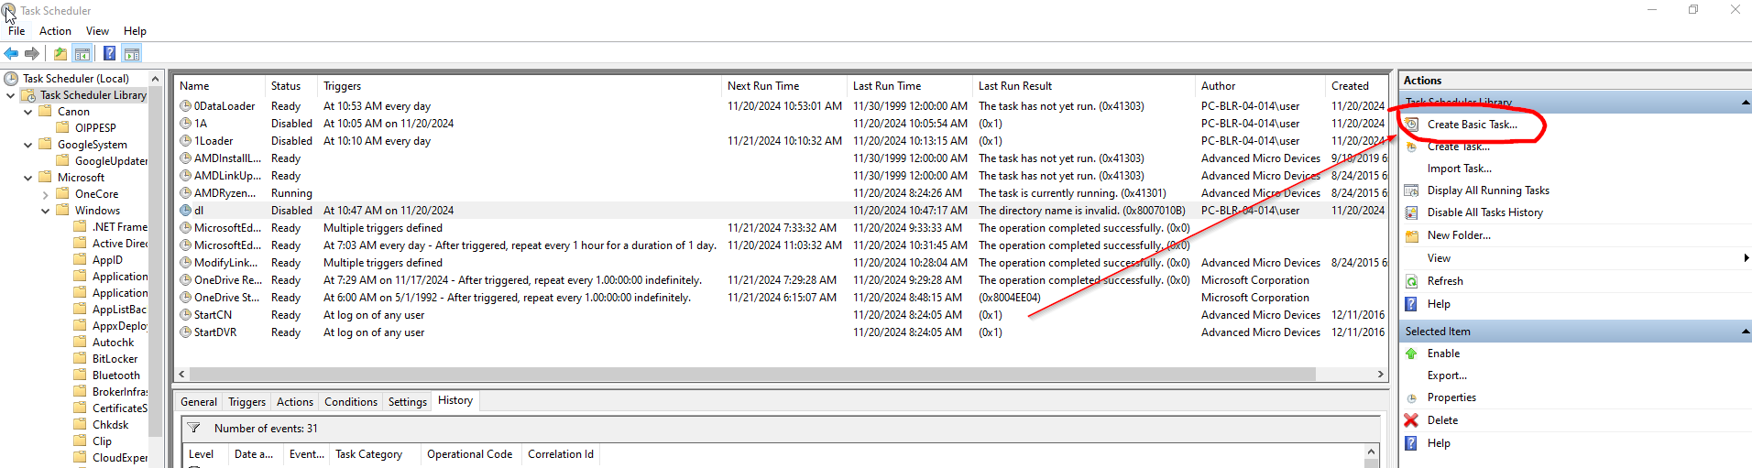

set Name / Trigger / Action (choose Start a program)
!!! for win10 in start in add path to folder where bat file is (otherwise will not execute bat)

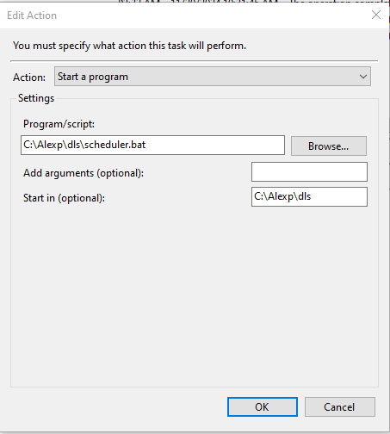

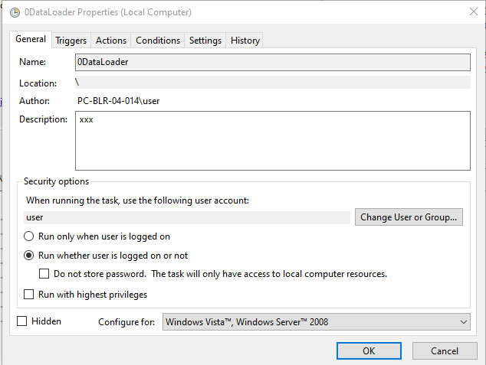
do not forget set user and condition to run

